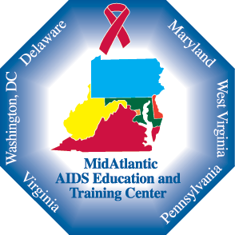 Fundamentals of HIV Infection

September 24, 2019

Bluefield State College, Bluefield WV

Description:
The MidAtlantic AIDS Education & Training Center's West Virginia Regional Partners’ mission is to increase providers' capacity to provide high quality HIV/AIDS care within our health care systems. Changes occur rapidly in the HIV/AIDS arena and all interested health care professionals should seek yearly updates to stay current.

Objectives:
Upon completion of this program, participants should be able to:
- Discuss current global, national and state HIV epidemiology and recognize the various modes of transmission.
- List the current HIV prevention models in place to reduce the numbers of new HIV infections in the United States.
- Discuss the ways in which opioid use and Syringe Exchange Programs impact HIV transmission.
- Explain the correlation between sexual history taking in the clinical setting and HIV transmission and recognize the Best Practices aimed at conducting a thorough sexual history and HIV risk assessment in the clinical setting.
- Discuss how HIV testing and implementation of testing in Primary Care and Community health Centers has impacted disease transmission and HIV infections in the United States.

Target Audience:
Nurses

Agenda:
800-815 Registration/Welcome
815-900 Fundamentals of HIV - Carolyn Kidd
900-945 HIV Prevention Update – Jeannette Southerly
945-1000 Break
1000-1100 Syringe Exchange, Opioids and HIV – Carolyn Kidd
1100-1200 Sexual History and Risk Assessment – Jeannette Southerly
1200-1245 HIV Testing – Carolyn Kidd
1245-100 Q&A, Evaluations

Presenters:
Carolyn Kidd RN, ACRN is the Clinical Nurse Educator for the West Virginia Local Performance Site. She has been on staff since 2003.
Jeannette Southerly RN, ACRN is the Regional Coordinator for the WV Local Regional Partner. She has been on staff since 1990.

Nursing Contact Hours Accreditation Statement:
This continuing education activity has been provided by the WV Regional Partner of the MidAtlantic AIDS Education and Training Center for 5.4 contact hours. The WV Regional Partner is an approved provider of continuing nursing education by the State of WV Board of Examiners for Registered Professional Nurses. WVBRN provider number 50-26128.21. This activity is also approved for Licensed Practical Nurses for 5.4 contact hours.

Disclosure Policy:
All those in a position to control content have indicated that they have no significant interests to disclose.

For more information contact Carolyn Kidd 304-293-6359

This program is supported by an educational grant from the Health Resources and Services Administration (HRSA). Grant # U10HA29295

